CALCULATION OF POLLUTANT EMISSIONS IN TRANSPORTATION ANALYSIS ZONES AND SPATIAL CORRELATION WITH URBAN PUBLIC SPACE

Diego A. Escobar
Universidad Nacional de Colombia, Sede Manizales. Facultad de Ingeniería y Arquitectura, departamento de Ingeniería Civil, Grupo de Investigación en Movilidad Sostenible. Campus la Nubia, Carrera 37 – Calle 94, Bloque S2 – oficina 208, Manizales, 170003, Colombia, daescobarga@unal.edu.co
Santiago Díaz-Ruiz
Universidad Nacional de Colombia, Sede Manizales. Facultad de Ingeniería y Arquitectura, departamento de Ingeniería Civil, Grupo de Investigación en Movilidad Sostenible. Campus la Nubia, Carrera 37 – Calle 94, Bloque S2 – oficina 208, Manizales, 170003, Colombia, sdiazru@unal.edu.co
Juan E. Aristizábal
Universidad Nacional de Colombia, Sede Manizales. Facultad de Ingeniería y Arquitectura, departamento de Ingeniería Civil, Grupo de Investigación en Movilidad Sostenible. Campus la Nubia, Carrera 37 – Calle 94, Bloque S2 – oficina 208, Manizales, 170003, Colombia, jaristizabals@unal.edu.co

ABSTRACT
The urban planning of the past century did not consider the benefits of service distribution and focused solely on the efficiency of mobility in motorized and/or private modes of transportation. This approach has resulted in significant negative externalities, including vehicular congestion, greenhouse gas emissions, air pollution, road accidents, and reduced quality of life. Currently, there is a paradigm shift in urban planning towards accessibility. Accessibility is defined as the ability to reach the opportunities offered by the city in a fair and responsible manner, particularly through sustainable transportation modes. Transportation modes include buses, which have a high transport capacity, as well as streetcars and aerial cables, which are environmentally friendly. Additionally, active transport options such as walking and bicycling, which do not have motors and therefore do not contribute to emissions, are also available. During the initial phase of this research, we calculated the CO2 equivalent emissions in Manizales' Transportation Analysis Zones (TAZ) by analyzing the current trips generated and attracted by these zones and their respective modal distribution. Additionally, we calculated the Public Space Index for each TAZ. Finally, spatial statistical methods were used to estimate the spatial correlation between CO2 equivalent emissions and the Public Space Index. This analysis allows for the characterization and clustering of the joint behavior of these two variables within the analyzed territory. It also provides evidence of a statistical trend between the provision of urban green space and atmospheric pollution. This research offers a tool for informed decision-making in urban planning and transportation.
Keywords: 15-minute city; CO2 emissions; public space; spatial statistics; urban planning

INTRODUCTION
In previous decades, the expansion and planning of cities were conducted in such a way that there was homogeneity in land use, needing to resort to a model in which mobility was focused on private motorized modes of transport to meet their transport needs (work, leisure, services, etc.). This has led to the centralization of services and large areas of the cities used for mobilization, generating the proliferation of negative externalities related to traffic congestion, high travel times, greenhouse gas emissions, air pollution, road accidents, related diseases, sedentary lifestyle, decrease in quality of life, among others (Victoria Transport Policy Institute, 2020). This has led to the fact that, at present, special urban planning studies and programs are needed.
These current planning tools define regulations that must be complied with by citizens and, in turn, a guiding instrument for decision-making entities to have defined tools in terms of land use and territorial development that allow cities or regions to achieve sustainable, efficient and balanced development (Bowley & Evins, 2020) that takes into account social, economic, and environmental areas with the use of parameters related to urban infrastructure, green areas, building category, land use, natural and protected areas, non-developable land, hydrology, among others (Khan & Pinter, 2016). Within these tools, specific items can be found such as prioritization of infrastructure works, architectural limits in the construction of buildings, urban activities allowed in space, minimum necessary distances between buildings of different uses, among others.
However, due to past planning and the ongoing needs of the population to mobilize (Carpio-Pinedo et al., 2021), the use of city planning tools should consider (Eldeeb et al., 2021; Farber & Marino, 2017; Geurs & van Wee, 2004) the inclusion of policies focused on discouraging trips in private motorized vehicles and promoting the use of active transport and public transport (Cepeda et al., 2017; Gori et al., 2012; Kinigadner et al., 2021). Not taking these mobility needs into account in the planning of cities and public transport perpetuates dependence on private vehicles, as happened in the Metropolitan Area of Bucaramanga according to Manrique et al. (2020), which was based on the expansion of residential and commercial sectors without considering the transport factor, resulting in a congested network and an illegal passenger transport increase.
As part of this new approach to planning, in 2016 Professor Carlos Moreno coined the concept of "15-minute city", which proposes to implement policies for the decentralization of services, achieving a mix of land uses so that people can reach services (Guo et al., 2023) and urban nodes with a short travel time, thus reducing the need for long journeys and generating a modal shift towards active media, thus improving the living conditions of inhabitants and providing sustainability, inclusiveness and equity to cities; to achieve this, it is proposed, among other things, a revitalization of public space through the distribution and use of these, making investments that improve their walkability conditions, accessibility and habitability so that they are part of the central axis of the populations and have a significant use in terms of mobility and leisure by citizens (Allam et al., 2022; Aristizábal et al., 2023).
Likewise, accessibility, defined as the potential to achieve the opportunities offered by the city in a fair and responsible way, is an integral part of planning focused on the proximity of services and the mixture of land and buildings, since they are distributed in such a way that they can be achieved in a short time and under more sustainable modes, such as active transport or public transport, some of the externalities caused by the excessive use of private motorized modes are mitigated (Cavoli, 2021; Escobar García & Urazán Bonells, 2014; Geurs & Ritsema van Eck, 2003; Mishalani et al., 2014; Papa et al., 2016; Timmons et al., 2016). In addition, accessibility should be considered, together with connectivity, for the design of interconnected neighborhoods that favor active transport travel (Dukić & Vukmirovic, 2012) and, thus, the improvement of walkability conditions (Cardona Urrea et al., 2023), quality of life (Southworth, 2005) and the promotion of sustainable urban development (Eldeeb et al., 2021; Feng et al., 2022; Hansen, 1959). Similarly, accessibility should also be used to reduce social inequality in the population expressed, in this case, as access to services (Guzman et al., 2020; Shen et al., 2017) (education, health, sports, leisure, supply, among others).
Among these services that must be planned and provided, and in order to achieve connectivity for active mobility (walking and cycling) of the highest quality, the need to have public spaces, such as parks, green areas and squares, that serve as drivers of social cohesion among citizens, improve the local economy and increase the perception of security (Allam et al., 2022; Carpio-Pinedo et al., 2021; D. Wang et al., 2013). This measure, successfully implemented in Barcelona, Spain in the "superblocks", has been studied and/or replicated in various cities globally (Almohamad et al., 2018; Barla et al., 2011; Dukić & Vukmirovic, 2012; Victoria Transport Policy Institute, 2020), has even led to the determination of public policies that require minimum public space present in cities, as is the case of the southern district of Jakarta, Indonesia, which establishes a minimum of 30 % of green space in its extension (Prinajati & Pratiwi, 2022).
In terms of transport, research such as the one carried out by (Lamb et al., 2021), shows until 2018 a production of 8.5 Gigatons of greenhouse gases derived from this activity, being historically responsible for 73 % of emissions; likewise, this sector presents an annual growth in emissions at an annual rate of 2 % derived from urban growth and travel distances (Cavoli, 2021), contributing to the deterioration of public health and the quality of life of citizens and going against the planning of the XXI century (Cardona Urrea et al., 2023; Cen et al., 2016). It has been found that planning decisions that favor the proximity of services and public space can lead to the reduction of externalities generated by motorized transport, with an emphasis on the reduction of CO₂ greenhouse gases (Feng et al., 2022; Guo et al., 2023; Han et al., 2015; Nowak & Crane, 2002; Papa et al., 2016; S. Wang et al., 2015; Zhang et al., 2018). Because of this, various methodologies have been proposed to make use of these flatteries in favor of urban planning. Research such as that conducted by Escobar G et al. (2022) and Cen et al. (2016) has provided tools to quantify the emissions produced by the transport of people under the different existing means of transport.
These estimations, studied using spatial statistics in conjunction with other variables (public space, motorization rate, modal distribution of trips, demographic characteristics, geographical characteristics, industrialization, GDP, among others), make it possible to determine spatial correlations between them and generate specific policies for each area of analysis, which focus on reducing emissions and thus contribute to a more sustainable, decentralized, human-scale cities, with a better quality of life and less dependence on motor vehicles (Cardona Urrea et al., 2023; Cavoli, 2021; Dukić & Vukmirovic, 2012; Eldeeb et al., 2021; Gori et al., 2012; Guo et al., 2023; Khan & Pinter, 2016; Lv et al., 2019).
Results of these methodologies previously applied have found correlations between land use and carbon emissions (Zhang et al., 2018) such as the strong negative correlation (-0.865) found between green space and CO₂ concentration in Jakarta, Indonesia, thus showing that from these studies technically informed decisions can be made that go in favor of environmental sustainability.
This research seeks to determine the correlation presented between public space and CO₂ equivalent emissions in the study area through spatial statistics, specifically the Bivariate Morán Index. According to the results, it is proposed to take actions that favor the reduction of emissions to move towards sustainability. The study is carried out in the Transport Analysis Zones (TAZ) of Manizales, an intermediate city of 460,000 located in the Colombian Andes at 2150 meters above sea level (masl), which although about ⅓ of its trips are made by active transport, has a very high motorization rate (1 vehicle for every 2 inhabitants), a very low vehicular occupancy (1.2 people per vehicle) and a high dependence on motorized modes of transport due to the topographical conditions of the terrain and, possibly, the demographics of its population. This city has 3 big eco parks (Los Alcázares, Los Yarumos and Bosque Popular El Prado) and public spaces of smaller and intermediate sizes distributed heterogeneously in their extension (Figure 1).
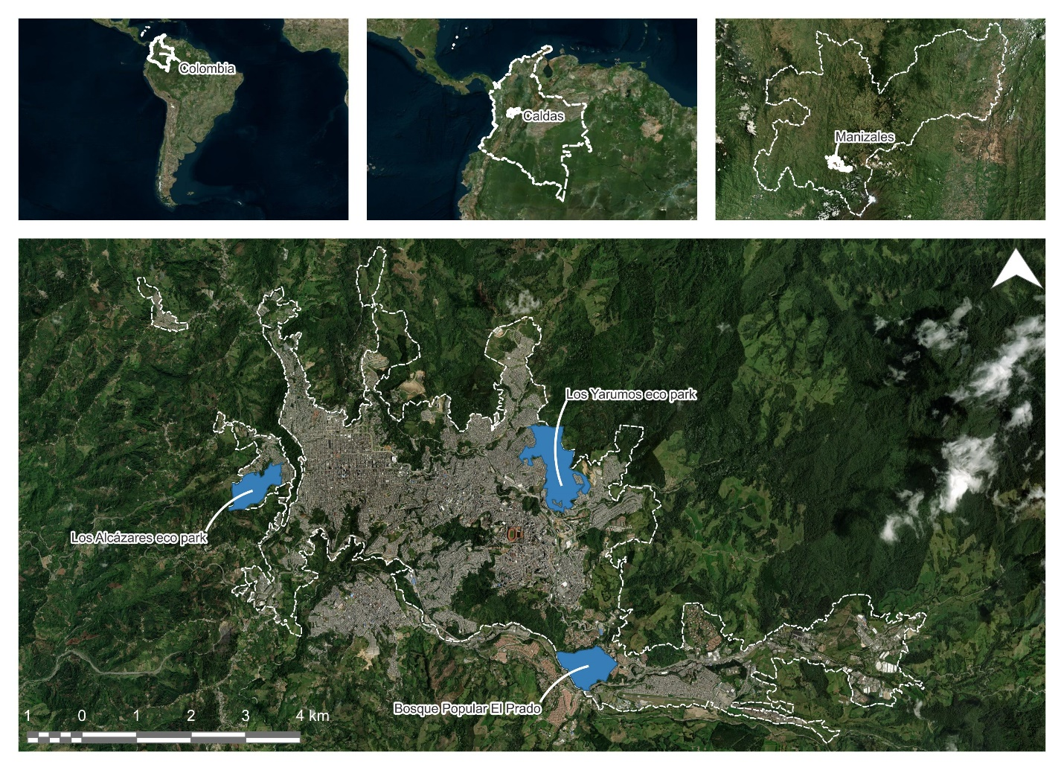
Figure 1. Manizales’s and its eco parks location. Source: authors.

METHODOLOGY
The methodology proposed for this study is summarized in Figure 2. A broad explanation of each stage is then provided.
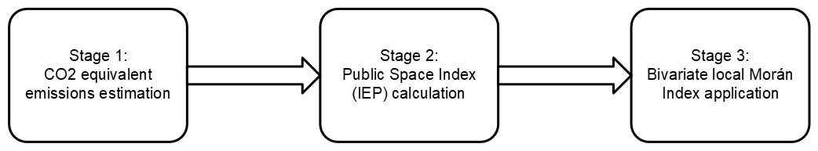
Figure 2. Purposed methodology. Source: authors.

Stage 1. CO₂ equivalent emissions estimation
Using methodologies such as the one proposed by Craig et al. (2008), pollutant emissions are calculated for each TAZ considering factors such as the mode of transport and its corresponding occupancy rate, types, efficiencies and calorific value of the fuels and the emission factors of each fuel, as shown in Equation 1.
$${CO}_{2}eq=F_{e}×F_{a}$$ |  | (1)
Where: | $F_{e}=$ Emission factor.  $F_{a}=$ Activity factor.

The emission factor ($F_{e}$) is related to the type of fuel used by the modes of transport evaluated (private vehicle, public transport, taxi and motorcycle). Each fuel has different emission factors and calorific values, which may differ between the different regions and refineries in which it is processed. Table 1 presents the values determined by the UPME - Unidad de Planeación Minero-Energética de Colombia (2016).
Table 1. Calorific values and emission factors for each fuel type. Source: UPME - Unidad de Planeación Minero-Energética de Colombia (2016).
Fuel | Calorific value  [TJ/gal] | Emission factor ($F_{e}$)  [kg/TJ]
Fuel | Calorific value  [TJ/gal] | CO₂ | CH₄ | C₂O
Gasoline | 0.0001139 | 66,778.4 | 33.0 | 3.2
Diesel | 0.0001373 | 74,831.8 | 1.0 | 0.6

The activity factor ($F_{a}$) is related to the operational properties of transport, such as the number of vehicles used, and the distances traveled by them. Based on the origin-destination matrix of trips in Manizales (Alcaldía de Manizales, 2017b), the number of trips made by each mode of transport in each TAZ to be analyzed is obtained. According to each mode of transport and considering the vehicle occupancy and efficiency set out in Table 2, it is possible to obtain the number of vehicles that must be mobilized to cover the trips made to each TAZ in each mode of transport.
Table 2. Vehicle occupancy and fuel efficiency by Transport mode. Source: Alcaldía de Manizales (2017b) y UPME - Unidad de Planeación Minero-Energética de Colombia (2016).
Transport mode | Fuel | Vehicle occupancy  [people/vehicle] | Efficiency  [km/gal]
Private vehicle | Gasoline | 1.8 | 33.0
Motorcycle | Gasoline | 1.2 | 50.0
Taxi | Gasoline | 1.2 | 99.0
Public transport | Diesel | 25 | 9.8

The distance traveled by each trip is obtained by constructing a matrix of minimum distances between the centroids of each TAZ using the city's vehicle infrastructure network in the TransCAD software, elements that are identified in Figure 3.
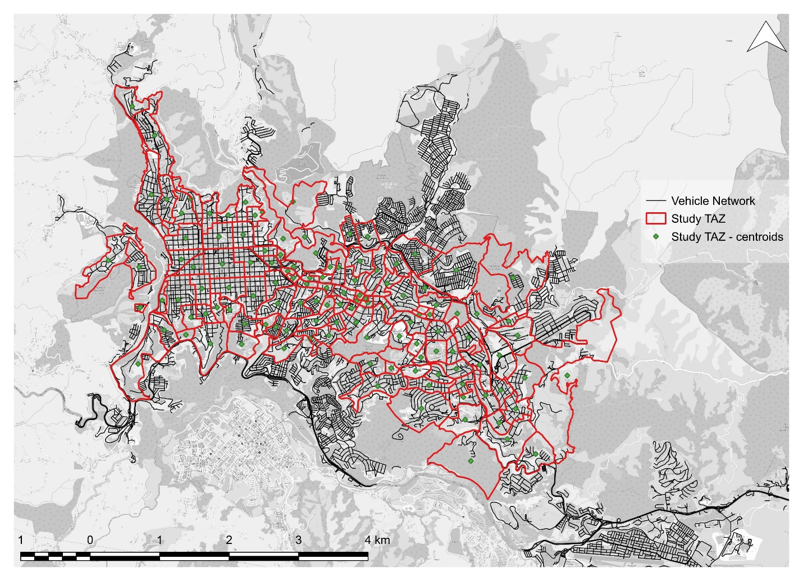
Figure 3. Vehicle network and study TAZ. Source: authors.
Finally, considering the aforementioned items, it is possible to calculate the amount of each fuel used to satisfy the trips made, which, together with the emission factors and calorific values, allows the equivalent CO2 emissions for each TAZ to be obtained.

Stage 2. Public Space Index (IEP) calculation
To know the Public Space Index (IEP), information is collected on the existence and area (Figure 4) (Alcaldía de Manizales, 2017a) of public spaces together with the population of each ZAT under study (Figure 5) (Alcaldía de Manizales, 2024). This index is calculated using Equation 2.
$$IEP=\frac{\sum{EP}}{hab}$$ |  | (2)
Where: | $\sum{EP}=$ Public space areas (green areas, parks, squares, etc.) [m²].  $hab=$ Study TAZ inhabitants [#]
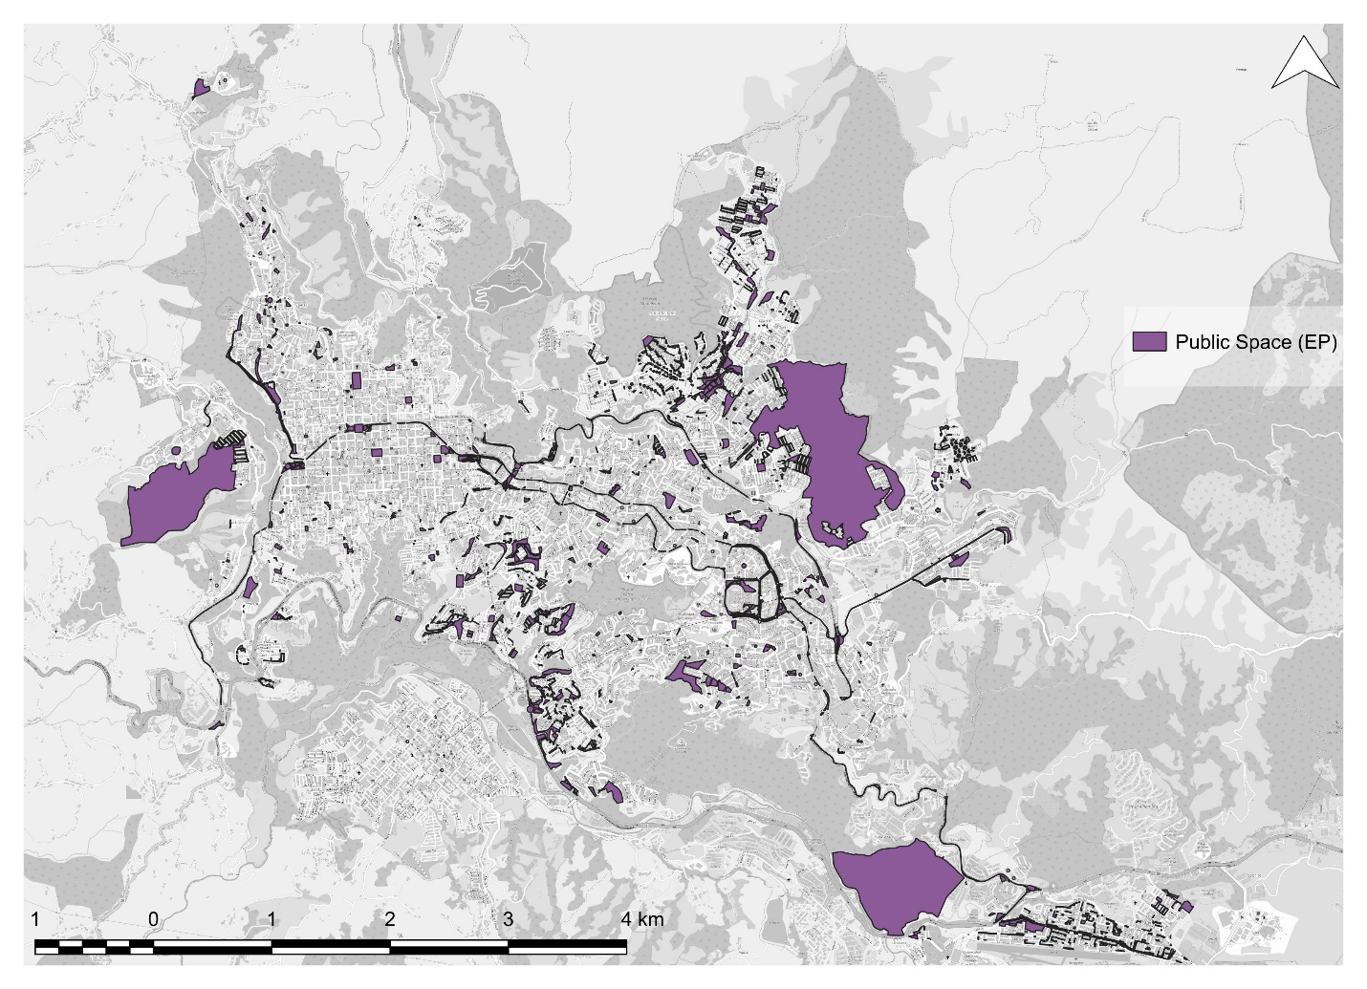
Figure 4. Public Space (EP). Source: Alcaldía de Manizales (2017a).
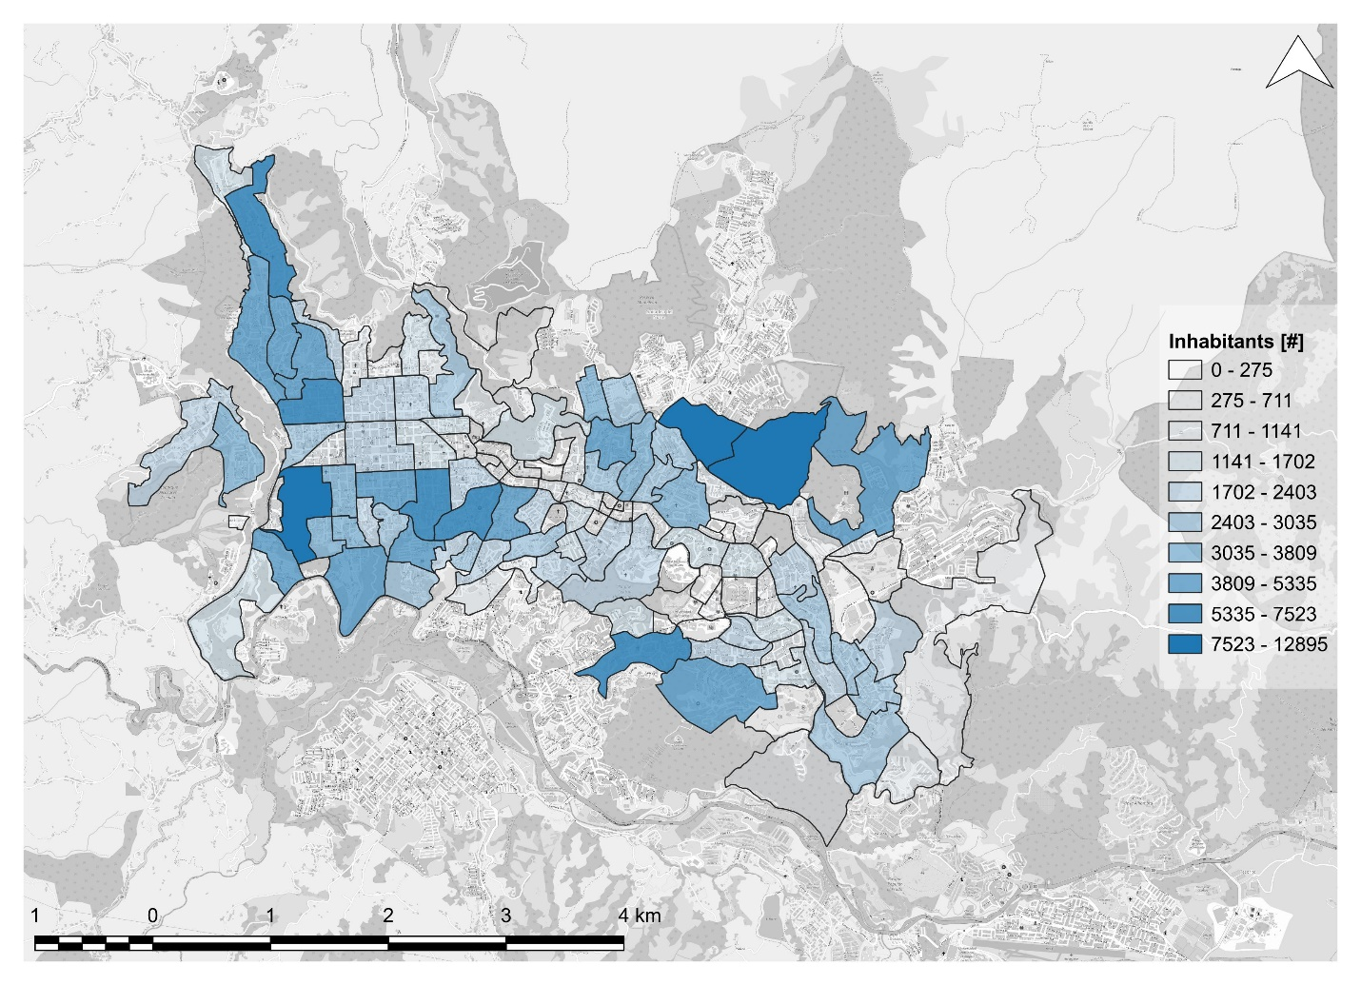
Figure 5. Inhabitants on the study TAZ. Source: Alcaldía de Manizales (2024).

Stage 3. Bivariate local Morán Index application
To develop the calculation of the bivariate local Morán Index between the CO2 equivalent emissions variables and the public space index, a database at the ZAT level containing both variables must be consolidated. Subsequently, an exploratory analysis of data on both variables is carried out to know the statistical distribution of each one, the existence of outliers, among others. For this, tools such as box plots, quantile-quantile plots, pair plots and the Shapiro-Wilk test are used.
After this exploratory data analysis, a series of transformations are applied to the variables with the aim of improving the trend towards normality in the distribution of the variables. For this, an iterative process is developed evaluating diverse types of statistical transformations, such as: root transformations, logarithmic transformation, Box-Cox transformation, among others. As a criterion for the application of the transformations, the Shapiro-Wilk test is used, whose null hypothesis is that the variable follows a normal distribution; Additionally, as a graphical support, the quantile-quantile graph is used to evaluate the trend of the variable towards normality.
Finally, the spatial analysis is carried out on the variables of CO2 equivalent emissions and the space index. First, the matrix of spatial weights is established, which is a fundamental mathematical entity in spatial analysis to define and establish the concept of statistical proximity between units of analysis. For this, the criterion of defining the matrix by first-order physical contiguity is used (Calafiore et al., 2022). After the definition of the spatial weights matrix, the local bivariate Morán Index is calculated among the analysis variables, with the aim of establishing the interaction of the geographical behavior of the emissions and the public space index. GeoDa software is used to perform the entire stage in question.

RESULTS AND DISCUSSION

Stage 1. CO₂ equivalent emissions estimation
The CO2 equivalent emissions obtained for each ZAT under study are presented. A concentration of emissions is found in the sectors of the economic poles (Aristizábal et al., 2023) of the Historic Center and El Cable, sectors where the labor and commercial activity of the city is concentrated. Likewise, considerable emission is observed in the eastern and western ends of the city, sectors that, as they do not present similarities in their uses, may be motivated by different situations, which may be due to the concentration of the eastern sector for commercial use while that of the western sector, for large residential use, could be manifesting a deficiency in its public transport offer. a situation that forces the use of more private vehicles and motorcycles, thus reducing their occupations and generating more emissions.
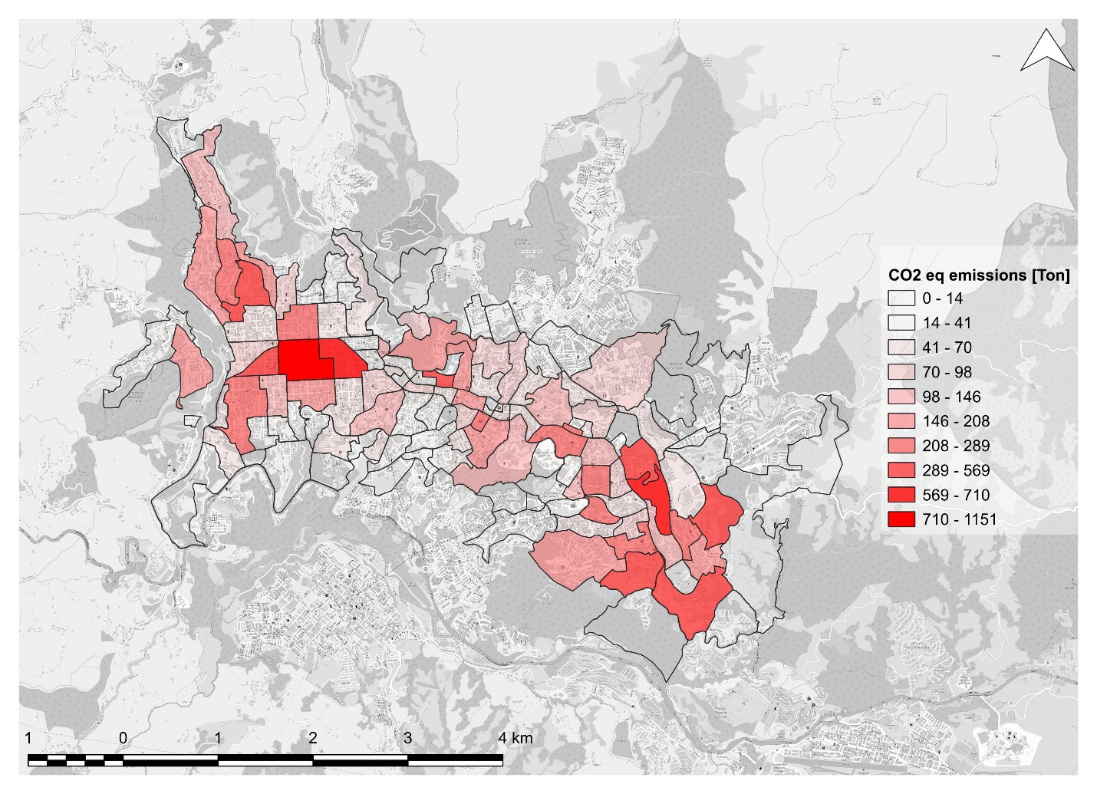
Figure 6. CO₂ equivalent emissions on the study TAZ. Source: authors.

Stage 2. Public Space Index (IEP) calculation
Figure 7 shows the Public Space Index (IEP) of the ZAT under study, obtaining an average of 4.60 m²/inhabitant in the city. Sectoring the results in the study TAZs, high values are found in the areas where the city's eco parks are located, where each person has more than 17 m2 of public space. It should be noted that there are no high IEP values in the economic poles of the city, a situation that should be considered in future planning of the city since, as these sectors are with a large generation/attraction of travel and, therefore, a large influx of people, it should be possible to have quality public spaces for their use and enjoyment.
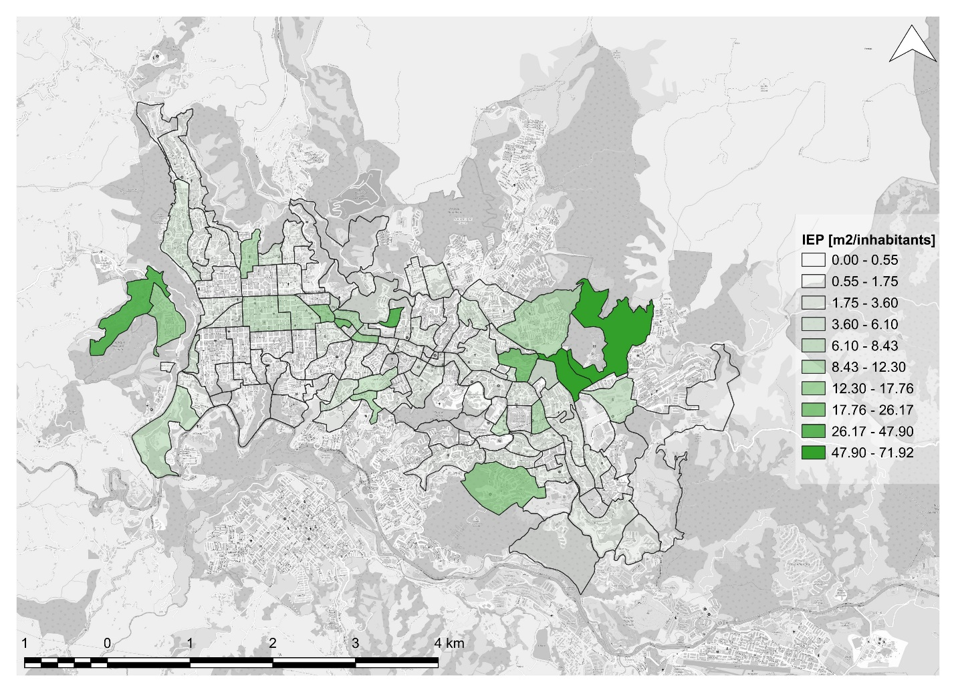
Figure 7. IEP on the study TAZ. Source: authors.

Stage 3. Bivariate local Morán Index application
For the last stage, it begins by developing an exploratory analysis of data in order to inquire about the variables of CO2 emissions (it appears on the labels of the figures as co2), IEP (iep) and their statistical distribution. First, the boxplots of the variables are obtained using Figure 8, appreciating the presence of a significant number of higher atypicals in both variables.
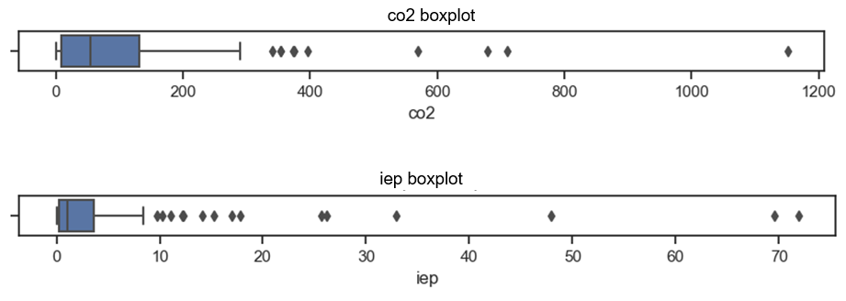
Figure 8. CO2 and IEP boxplot. Source: authors.
Then, a pair plot is plotted between variables (Figure 9) in order to know their distribution and the partial correlation between them. Clear positive asymmetries (on the left) can be seen in both variables.
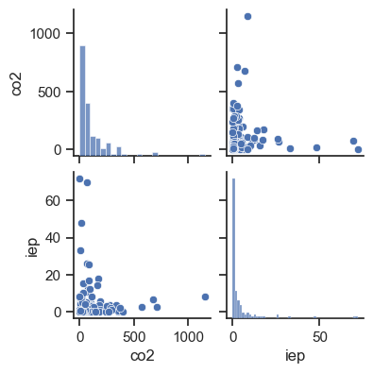
Figure 9. Pair plot between CO₂ and IEP. Source: authors.
To evaluate the trend towards normality of the variables, the Q-Q plot is plotted for each variable (Figure 10), where it is evident that there is a great statistical bias and the variables do not follow a Gaussian (normal) distribution.
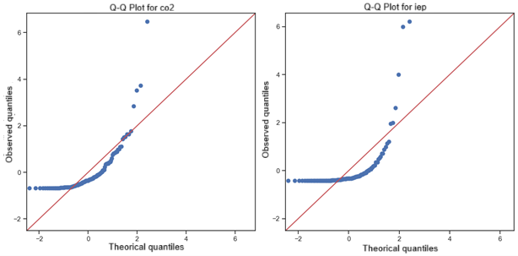
Figure 10. Q-Q plot graphic of CO₂ and IEP. Source: authors.
To corroborate this mathematically, the Shapiro-Wilk test is applied, whose null hypothesis states that the data follow a normal distribution. In both cases, the p-value is less than 0.05 and, therefore, the null hypothesis that the variables have a normal distribution is rejected (Table 3).
Table 3. Shapiro-Wilk test to CO₂ and IEP. Source: authors.
Variable | Test Shapiro-Wilk | p-value
co2 | 0,649566 | 0,000000
iep | 0,436313 | 0,000000

By testing a series of transformations, it is proved that, in this case, the most appropriate distribution is the fourth root for both variables. Thus, the transformed variables show the statistical graphical results shown in Figure 11 and Figure 12.
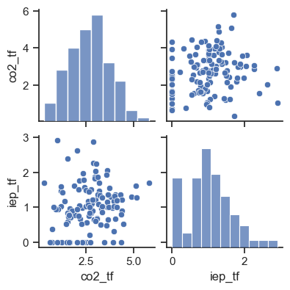
Figure 11. Pair plot between transformed CO₂ and IEP. Source: authors.
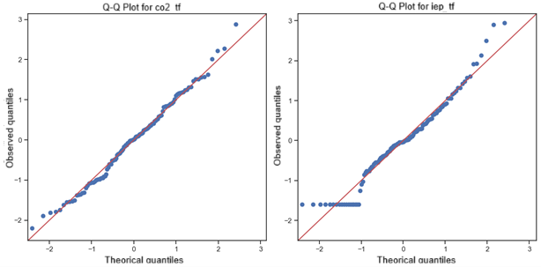
Figure 12. Q-Q plot graphic of transformed CO₂ and IEP. Source: authors.

Next, the matrix of spatial weights (W) is created, whose definition criterion was first-order physical contiguity. With the spatial weights matrix defined, the bivariate local Morán Index is estimated for the two study variables. Initially, Figure 13 presents the map of the hypothesis test applied prior to the definition of spatial clusters. The map shows that, of the ZAT under study, 23 generate some type of clustering with their respective level of statistical significance. In the eastern part of the city, it can be seen that the clusters have lower values in their hypothesis test, that is, a higher level of statistical significance.
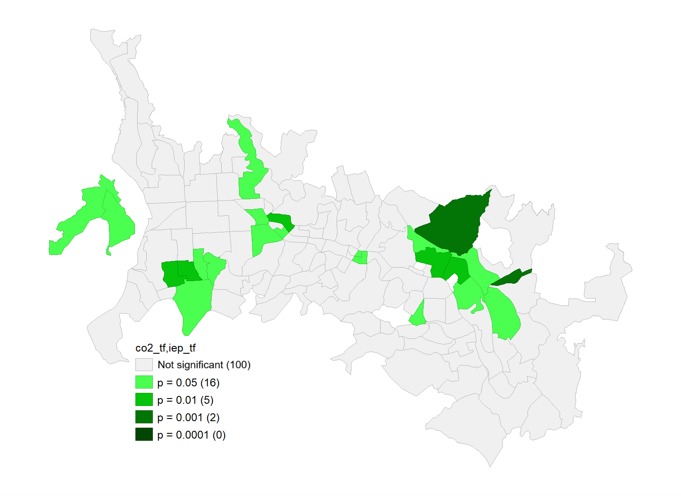
Figure 13. Hypothesis test values for the bivariate local Morán Index. Source: authors.
In the clustering analysis, it is initially seen that there is a Morán Index between both variables of 0.034, which shows a very low spatial association between the variables analyzed. However, in the cluster map, the presence of 8 high-high cluster TAZ can be seen, forming 3 clusters with hot spots, 8 low-low cluster TAZs, forming 3 clusters with cold spots and 6 low-high clusters and one high-low cluster (Figure 14).
As for the hot spots, these are made up of 8 TAZ that are located mainly in the east of the city, in areas that register high CO2 emissions equivalent to high indices of public space. Another high-high cluster can be seen near the Historic Center of the city, and another hot cluster in the west of the city. As for the cold spots, these are made up of 8 ZATs that are located mainly south of the Historic Center of the city, in areas with low emissions and low levels of public space. In addition, there are other low-low cluster areas towards the north of the city and in a ZAT towards the geographical center of the analysis area.
Finally, 6 spatial clusters are appreciated in the analysis of areas with low levels of polluting emissions and high rates of public space, which are located in various places of the city: western zone, east of the Historic Center and east of the city; In all cases, it can be seen that these low-high clusters are adjacent to high-high clusters. On the other hand, the presence of a single high-low cluster located towards the eastern part of the city can be seen to the south the large high-high cluster.
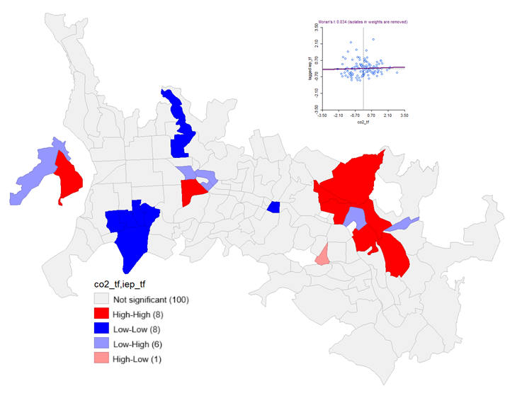
Figure 14. Clusters and bivariate local Morán Index graph. Source: authors.
The geographical representation of clusters in the analysis area establishes that, although the bivariate Morán Index exhibits a very low spatial association between the variables, there are areas of the city where a grouping of the variables is generated. However, there is a greater trend towards the existence of hot and cold spots, rather than the generation of high-low or low-high clusters.

CONCLUSIONS
There is a high emission of CO2 in the 2 most important economic poles of the city (Historic Center and El Cable), as a result of the high use of motor vehicles and the high generation/attraction of trips. In turn, there is a considerable emission to the eastern sector of El Cable and to the northern sector of the Historic Center; The high use of motor vehicles in these areas may be associated with a possible deficiency in the supply of public transport and a high purchasing power of their inhabitants, and the high flow of trips in these areas may be associated with the mixture in the use of their land and the high availability of services. properly known as economic poles, causing trips to be made in modes with high emission rates, such as cars and motorcycles). It is recommended that decisions be made to improve the infrastructure and supply of more sustainable modes of transport, either focused on public transport or active mobility, which can be complemented with urban planning measures that allow the proximity of services throughout the territory; In addition, it is proposed to adopt demand management measures that discourage the use of motorized transport and its transfer to modes with less environmental impact.
The city's Public Space Index (IEP) shows low values in most of the ZAT under study with respect to the values recommended by international organizations; for the entire area of analysis, an average value of 4.60 m2/inhabitant is obtained, this being a value lower than the one recommended by the World Health Organization (15 m2/inhabitant). The adoption of public policies that guarantee the existence of these spaces should be considered, such as in cities such as Bogotá (Colombia), in which the Public Space Index recommended by the WHO is guaranteed.
Regarding the results of spatial correlation between the CO2 equivalent emission variables and the IEP, there is no statistical evidence of a spatial relationship between the two. It is thus concluded that, in the case of Manizales, planning efforts should be focused on other actions (the distribution of services, the improvement of the public transport offer, among others) to reduce the emissions of polluting gases produced by the transport of people.
In this sense, this research proposes an initial tool to explore the generation of emissions from mobile sources and, in this way, develop methodologies that consider this factor in a more detailed sense; In addition, future research may consider the development of more complex statistical models, which include another series of variables theoretically associated as a cause or consequence of emissions, seeking to broadly characterize this parameter. For this, regression analysis with spatial emphasis, weighted geographic regression, among other methods, can be used.

ACKNOWLEDGMENTS
The researchers would like to thank the members of Sustainable Mobility Research Group (GIMS) of the Universidad Nacional de Colombia, Manizales. This research is part of the “CALL OF THE FACULTY OF ENGINEERING AND ARCHITECTURE OF THE NATIONAL UNIVERSITY OF COLOMBIA, MANIZALES BRANCH -2024 FOR THE SUPPORT OF RESEARCH AND ARTISTIC CREATION PROJECTS IN ALLIANCE WITH EXTERNAL ENTITIES OR INSTITUTIONS OF HIGHER EDUCATION” through the proposal entitled: “Methodological proposal for the Social Cost Benefit Analysis given the implementation of sustainable transport modes in an urban area.”

REFERENCES
Alcaldía de Manizales. (2017a). Plan de Ordenamiento Territorial de Manizales 2017 - 2031.
Alcaldía de Manizales. (2017b). Plan Maestro de Movilidad de Manizales. http://www.infimanizales.com/wp-content/uploads/2018/06/Plan-Maestro-de-Movilidad-Manizales-PDF.pdf
Alcaldía de Manizales. (2024). Laboratorio de Innovación Pública. Población de Manizales por comunas. https://laboratorio.manizales.gov.co/modulo-poblacion/
Allam, Z., Bibri, S. E., Chabaud, D., & Moreno, C. (2022). The ‘15-Minute City’ concept can shape a net-zero urban future. In Humanities and Social Sciences Communications (Vol. 9, Issue 1). Springer Nature. https://doi.org/10.1057/s41599-022-01145-0
Almohamad, H., Knaack, A. L., & Habib, B. M. (2018). Assessing spatial equity and accessibility of public green spaces in Aleppo City, Syria. Forests, 9(11), 1–22. https://doi.org/10.3390/f9110706
Aristizábal, J. E., Sarache, W., & Escobar, D. A. (2023). Spatial Regression Model of Urban Walkability Under the 15-minute City Approach. Geojournal of Tourism and Geosites, 49(3), 1037–1045. https://doi.org/10.30892/gtg.49319-1103
Barla, P., Miranda-Moreno, L. F., & Lee-Gosselin, M. (2011). Urban travel CO2 emissions and land use: A case study for Quebec City. Transportation Research Part D: Transport and Environment, 16(6), 423–428. https://doi.org/10.1016/j.trd.2011.03.005
Bowley, W., & Evins, R. (2020). Assessing energy and emissions savings for space conditioning, materials and transportation for a high-density mixed-use building. Journal of Building Engineering, 31. https://doi.org/10.1016/j.jobe.2020.101386
Calafiore, A., Dunning, R., Nurse, A., & Singleton, A. (2022). The 20-minute city: An equity analysis of Liverpool City Region. Transportation Research Part D: Transport and Environment, 102. https://doi.org/10.1016/j.trd.2021.103111
Cardona Urrea, S., Escobar, D. A., & Sarache, W. (2023). Social Cost - Benefit Analysis of Active Mobility Projects in Contexts With Steep Terrain. A Case Study in Colombia. Geojournal of Tourism and Geosites , 49(3), 1056–1066. https://doi.org/10.30892/gtg.49321-1105
Carpio-Pinedo, J., Benito-Moreno, M., & Lamíquiz-Daudén, P. J. (2021). Beyond land use mix, walkable trips. An approach based on parcel-level land use data and network analysis. Journal of Maps, 00(0), 1–8. https://doi.org/10.1080/17445647.2021.1875063
Cavoli, C. (2021). Accelerating sustainable mobility and land-use transitions in rapidly growing cities : Identifying common patterns and enabling factors. Journal of Transport Geography, 94(April), 103093. https://doi.org/10.1016/j.jtrangeo.2021.103093
Cen, X., Lo, H. K., & Li, L. (2016). A framework for estimating traffic emissions: The development of Passenger Car Emission Unit. Transportation Research Part D: Transport and Environment, 44, 78–92. https://doi.org/10.1016/j.trd.2016.02.013
Cepeda, M., Schoufour, J., Freak-Poli, R., Koolhaas, C. M., Dhana, K., Bramer, W. M., & Franco, O. H. (2017). Levels of ambient air pollution according to mode of transport: a systematic review. The Lancet Public Health, 2(1), e23–e34. https://doi.org/10.1016/S2468-2667(16)30021-4
Craig, L., Brook, J. R., Chiotti, Q., Croes, B., Gower, S., Hedley, A., Krewski, D., Krupnick, A., Krzyzanowski, M., Moran, M. D., Pennell, W., Samet, J. M., Schneider, J., Shortreed, J., & Williams, M. (2008). Air pollution and public health: A guidance document for risk managers. In Journal of Toxicology and Environmental Health - Part A: Current Issues (Vol. 71, Issues 9–10, pp. 588–698). https://doi.org/10.1080/15287390801997732
Dukić, A., & Vukmirovic, M. (2012). Redesigning the network of pedestrian Spaces in the function of reduction of CO2 Emission. Case study: Pančevo and Vršac. Spatium, 27, 31–39. https://doi.org/10.2298/SPAT1227031D
Eldeeb, G., Mohamed, M., & Páez, A. (2021). Built for active travel? Investigating the contextual effects of the built environment on transportation mode choice. Journal of Transport Geography, 96(August). https://doi.org/10.1016/j.jtrangeo.2021.103158
Escobar G, D. A., Sarache, W., & Jiménez-Riaño, E. (2022). The impact of a new aerial cable-car project on accessibility and CO2 emissions considering socioeconomic stratum. A case study in Colombia. Journal of Cleaner Production, 340. https://doi.org/10.1016/j.jclepro.2022.130802
Escobar García, D. A., & Urazán Bonells, C. F. (2014). Accesibilidad territorial: instrumento de planificación urbana y regional. Revista Tecnura, 18, 241. https://doi.org/10.14483/udistrital.jour.tecnura.2014.se1.a18
Farber, S., & Marino, M. G. (2017). Transit accessibility, land development and socioeconomic priority: A typology of planned station catchment areas in the Greater Toronto and Hamilton area. Journal of Transport and Land Use, 10(1), 33–56. https://doi.org/10.5198/jtlu.2017.980
Feng, T., Huang, Y., & Zhou, B. (2022). Carbon emissions and in-building open public spaces: a case study on hypothetical building models in Shanghai. Open House International, 47(3), 451–472. https://doi.org/10.1108/OHI-10-2021-0216
Geurs, K. T., & Ritsema van Eck, J. R. (2003). Evaluation of accessibility impacts of land-use scenarios: The implications of job competition, land-use, and infrastructure developments for the Netherlands. Environment and Planning B: Planning and Design, 30(1), 69–87. https://doi.org/10.1068/b12940
Geurs, K. T., & van Wee, B. (2004). Accessibility evaluation of land-use and transport strategies: Review and research directions. Journal of Transport Geography, 12(2), 127–140. https://doi.org/10.1016/j.jtrangeo.2003.10.005
Gori, S., Nigro, M., & Petrelli, M. (2012). The impact of land use characteristics for sustainable mobility: The case study of Rome. European Transport Research Review, 4(3), 153–166. https://doi.org/10.1007/s12544-012-0077-6
Guo, L., Cheng, W., Liu, C., Zhang, Q., & Yang, S. (2023). Exploring the Spatial Heterogeneity and Influence Factors of Daily Travel Carbon Emissions in Metropolitan Areas: From the Perspective of the 15-min City. Land, 12(2). https://doi.org/10.3390/land12020299
Guzman, L. A., Escobar, F., Peña, J., & Cardona, R. (2020). A cellular automata-based land-use model as an integrated spatial decision support system for urban planning in developing cities: The case of the Bogotá region. Land Use Policy, 92(December 2019), 104445. https://doi.org/10.1016/j.landusepol.2019.104445
Han, S. S., Wang, Y. Q., Ramachandra, T. V., & Qin, B. (2015). The Impact of Spatial Parameters on Carbon Dioxide (CO2) Emissions: A Comparative Study between Cities in China and India. APN Science Bulletin. https://doi.org/10.3141/1780-10
Hansen, W. G. (1959). How Accessibility Shapes Land Use. Journal of the American Planning Association, 25(2), 73–76. https://doi.org/10.1080/01944365908978307
Khan, F., & Pinter, L. (2016). Scaling indicator and planning plane: An indicator and a visual tool for exploring the relationship between urban form, energy efficiency and carbon emissions. Ecological Indicators, 67, 183–192. https://doi.org/10.1016/j.ecolind.2016.02.046
Kinigadner, J., Büttner, B., Vale, D., & Wulfhorst, G. (2021). Shifting perspectives: A comparison of travel-time-based and carbon-based accessibility landscapes. Journal of Transport and Land Use, 14(1), 345–365. https://doi.org/10.5198/jtlu.2021.1741
Lamb, W. F., Wiedmann, T., Pongratz, J., Andrew, R., Crippa, M., Olivier, J. G. J., Wiedenhofer, D., Mattioli, G., Khourdajie, A. Al, House, J., Pachauri, S., Figueroa, M., Saheb, Y., Slade, R., Hubacek, K., Sun, L., Ribeiro, S. K., Khennas, S., De La Rue Du Can, S., … Minx, J. (2021). A review of trends and drivers of greenhouse gas emissions by sector from 1990 to 2018. Environmental Research Letters, 16(7). https://doi.org/10.1088/1748-9326/abee4e
Lv, Q., Liu, H., Yang, D., & Liu, H. (2019). Effects of urbanization on freight transport carbon emissions in China: Common characteristics and regional disparity. Journal of Cleaner Production, 211, 481–489. https://doi.org/10.1016/j.jclepro.2018.11.182
Manrique, J., Cordera, R., Moreno, E. G., & Oreña, B. A. (2020). Equity analysis in access to Public Transport through a Land Use Transport Interaction Model. Application to Bucaramanga Metropolitan Area-Colombia. Research in Transportation Business and Management, September, 100561. https://doi.org/10.1016/j.rtbm.2020.100561
Mishalani, R. G., Goel, P. K., Westra, A. M., & Landgraf, A. J. (2014). Modeling the relationships among urban passenger travel carbon dioxide emissions, transportation demand and supply, population density, and proxy policy variables. Transportation Research Part D: Transport and Environment, 33, 146–154. https://doi.org/10.1016/j.trd.2014.08.010
Nowak, D. J., & Crane, D. E. (2002). Carbon storage and sequestration by urban trees in the USA. Environmental Pollution, 116, 381–389. www.elsevier.com/locate/envpol
Papa, E., te Brömmelstroet, M., Silva, C., & Hull, A. (2016). Accessibility instruments for planning practice: A review of European experiences. Journal of Transport and Land Use, 9(3), 57–75. https://doi.org/10.5198/jtlu.2015.585
Prinajati, P. D., & Pratiwi, R. (2022). The correlation of CO concentration and green open space (case study of Jagakarsa District, South Jakarta). Jurnal Pengelolaan Sumberdaya Alam Dan Lingkungan, 12(4), 660–668. https://doi.org/10.29244/jpsl.12.4.660-668
Shen, Y., Sun, F., & Che, Y. (2017). Public green spaces and human wellbeing: Mapping the spatial inequity and mismatching status of public green space in the Central City of Shanghai. Urban Forestry and Urban Greening, 27(August 2016), 59–68. https://doi.org/10.1016/j.ufug.2017.06.018
Southworth, M. (2005). Designing the walkable city. Journal of Urban Planning and Development, 131(4), 246–257. https://doi.org/10.1061/(ASCE)0733-9488(2005)131:4(246)
Timmons, D., Zirogiannis, N., & Lutz, M. (2016). Location matters: Population density and carbon emissions from residential building energy use in the United States. Energy Research and Social Science, 22, 137–146. https://doi.org/10.1016/j.erss.2016.08.011
UPME - Unidad de Planeación Minero-Energética de Colombia. (2016). Factores de emisión de los combustibles FECOC. http://www.upme.gov.co/calculadora_emisiones/aplicacion/calculadora.html
Victoria Transport Policy Institute. (2020). Land Use Impacts on Transport.
Wang, D., Brown, G., & Mateo-Babiano, I. (2013). Beyond Proximity: an Integrated Model of Accessibility for Public Parks. Asian Journal of Social Sciences & Humanities, 2(3), 486–498.
Wang, S., Fang, C., Wang, Y., Huang, Y., & Ma, H. (2015). Quantifying the relationship between urban development intensity and carbon dioxide emissions using a panel data analysis. Ecological Indicators, 49, 121–131. https://doi.org/10.1016/j.ecolind.2014.10.004
Zhang, R., Matsushima, K., & Kobayashi, K. (2018). Can land use planning help mitigate transport-related carbon emissions? A case of Changzhou. Land Use Policy, 74, 32–40. https://doi.org/10.1016/j.landusepol.2017.04.025

